# _LITfinalLOGO

# SUMMER EXAMINATIONS 2012

**Thursday, 17th May 2012, 14.30 p.m. – 17.30 p.m.**

**KSDEM\_8\_Y2**

**Course:** Bachelor of Science (Hons) in Software Development

**Year:** Two

**Subject:** Data Driven Applications

**Time Allowed:** 3 Hours

**Instructions: 1. ANSWER FOUR (4) QUESTIONS AS FOLLOWS**

* ANSWER Question **One (1)** in **PART A**
* ANSWER Question **Two (2)** **OR** Question **Three (3)** in **PART A**
* ANSWER Question **Four (4) AND Five (5)** in **PART B**

**2.** Indicate clearly on the front of the answer book which

questions have been attempted.

**Additional Attachments Exam Materials to accompany this paper:**

### Candidates are permitted to access their instance of Microsoft SQL Server which is required to complete the practical questions.

**Internal Examiners: External Examiners:**

Mr. Gerry Guinane Mr. Paul Powell

**PART A: Written answers required**

**Q1. DATABASE SYSTEMS TERMINOLOGY**

**a)** What are the major components of a Database System (DBS)? Briefly describe each component using an appropriate example of each to illustrate your answer. Describe the logical architecture of a DBS with the aid of a diagram.  **(4 marks)**

**b)** What is ADO.NET? Briefly describe the main purpose of the following

classes :

* System.Data.SqlClient.SqlConnection
* System.Data.SqlClient.SqlDataAdapter
* System.Data.DataSet. **(6 marks)**

**c)** What are the main types of user of a Database System? Provide a

brief description of each type of user and the typical tasks they engage

in. **(5 marks)**

**d)** In the context of logical database design what is E/R modelling? What are the diagrammatic conventions used to illustrate the various different relationships that can exist between entities? **(5 marks)**

**(Total 20 Marks)**

**Q2. RELATIONAL NOTATION and Transact-SQL (T-SQL)**

Before answering this question carry out the following tasks:

1. Create a new database “Q2COLLEGEDB” on your instance of

Microsoft SQL Server.

1. Locate the T-SQL script “SQLQueryCOLLEGE.sql” in the Q2

folder on your exam drive.

1. Execute the “SQLQueryCOLLEGE.sql” script in your instance of

Microsoft SQL Server.

1. With reference to the Q2COLLEGEDB database - use Relational Notation to write a complete description of the database and each of its tables. Ensure that primary keys, foreign keys and data types are clearly identified.

**(13 marks)**

**b)** Explain each of the SQL terms DML and DDL – what are they and

what are they used for? Provide three SQL keyword examples of both. **(8 marks)**

**c)** Write and execute the multiline Transact-SQL query required to add

the following data to the STUDENT Table. Save the query on your server instances default location as “Q2query.sql”:

StudentID Firstname Lastname

K0001234 Peter Smith

K0004321 James O’Connor

**(5 marks)**

**d)** Perform a full backup on your server of the Q2COLLEGEDB database.

**(4 marks)**

**(Total 30 Marks)**

**Q3. Logical Database Design – Functional Dependency**

Practical tasks:

Task 1: Download the database backup ‘itschool.sql’ file provided in your

exam drive (Folder Q3).

Task 2: Restore the ‘itschool’ database to MySQL

**a)** Describe, using an appropriate example taken from the ‘itschool’

database, what is meant by a functional dependency. **(5 marks)**

**b)** What is meant by first, second and third normal form? **(7 marks)**

**c)** Draw a functional dependency diagram for each of the tables in the

‘itschool’ database. Are all tables in the itschool database in 3rd normal form? Justify your answer.  **(10 marks)**

**d)** Given the following initial functional dependency diagram which is in

first normal form – use the table splitting technique to normalise the diagram to 3rd normal form. Show and fully label all intermediate steps. **(8 marks)**

Functional Dependency Diagram:

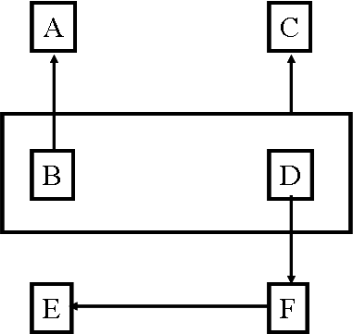

**(Total 30 Marks)**

**PART B: Practical Tasks**

IMPORTANT!! Save your work REGULARLY

Note: You are required to log on to your instance of SQL Server and complete the following series of tasks. Question 4 must be completed before attempting Question 5. Your logon instance is listed in the exam drive – filename “SQL Server Instances.docx”

**Q. 4 DATABASE IMPLEMENTATION – BANK DATABASE**

Given the following Relational Notation description of a database called ‘BANKDB’. Implement the Database in your instance of Microsoft SQL Server.

BANKDB={ BRANCH, EMPL, CURRENTAC, CUSTOMER, EMPLOYEE\_HISTORY, ACCOUNTS\_HELD}

BRANCH={ **BRnr**, BRaddress}

EMPL={ **EMPnr**, EMPfirstname, EMPlastname, EMPphone, EMPbranch}

Where:

* EMPfirstname, EMPlastname, are data type ‘nchar(30)’

CURRENTAC={ **ACCnr**, ACCbranch}

CUSTOMER={ **CUSTnr**, CUSTfirstname, CUSTlastname,

CUSTaddress }

Where:

* CUSTfirstname, CUSTlastname,CUSTaddress are data type ‘nchar(30)’

EMPLOYEE\_HISTORY={ **EMPid, DATE ,**EMPsalary, EMPtitle }

Where

* EMPid is a FK referencing EMPnr in the EMPL table

ACCOUNTS\_HELD={ **ACCnr** , **CUSTnr** , ACCbalance}

Where

* ACCnr is a FK referencing ACCnr in the CURRENTAC table
* CUSTnr is a FK referencing CUSTnr in the CUSTOMER table
* ACCbalance is data type ‘smallmoney’

Notes:

**a)** All data types are ‘nchar(10)’ unless otherwise stated

**b)** Primary Keys are in bold type and underlined.

**(Total 30 Marks)**

**Q. 5 DATABASE APPLICATION PROGRAMMING**

Note: Question 4 must be completed before attempting this question.

**a)** Add the following data to the CUSTOMER table in the BANKDB you

have set up on your instance of Microsoft SQL Server in Question 4.

|  |  |  |  |
| --- | --- | --- | --- |
| **CUSTnr** | **CUSTfirstname** | **CUSTlastname** | **CUSTaddress** |
| C1232225 | James | Morgan | Limerick |
| C25213341 | Conall | Mullarkey | Galway |
| C85987543 | Hugh | McGovern | Dublin |
| C69876254 | Mary | Byrne | Dublin |

**(3 marks)**

**b)** Locate and open the Visual C# “ BankDBApp.sln” project in the Q5/BankDBApp folder. Examine the code behind the main FORM page which looks like this:.

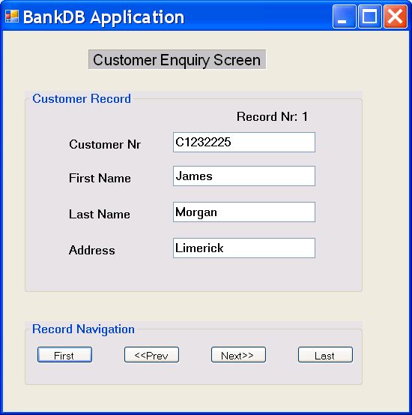

* You will see 10 (ten) comments labelled “TODO”
* Carry out the instructions contained in each of these TODO comments to create a fully working database application.

**(17 marks)**

**(Total 20 Marks)**